 | Autumn 1 | Autumn 2 | Spring 1 | Spring 2 | Summer 1 | Summer 2
 | Who am I? | If you go down to the woods today… | Superheroes | Down on the farm | Once upon a time... | On safari
Text(s) | 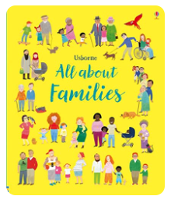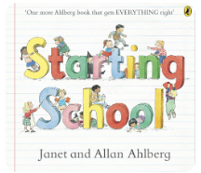 | 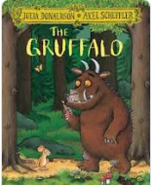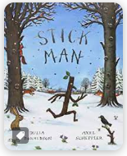 | 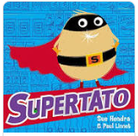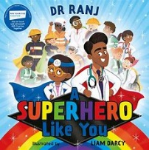 | 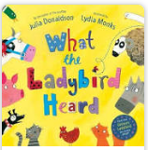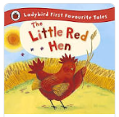 | 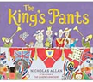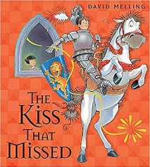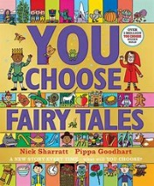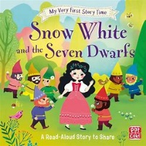 | 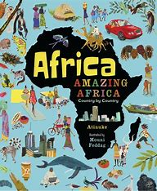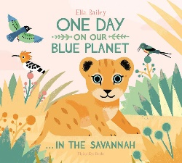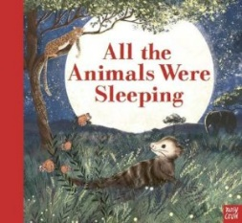
Supporting Texts | 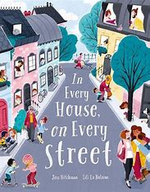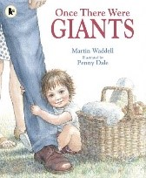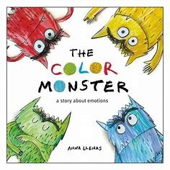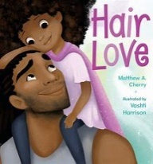  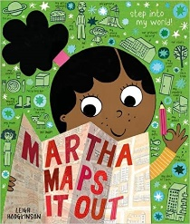 | 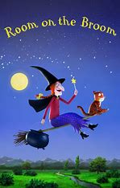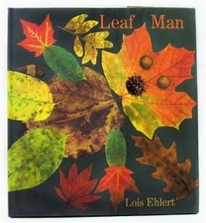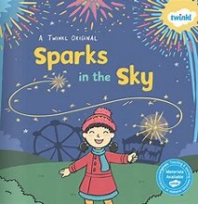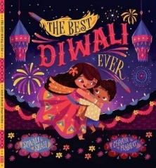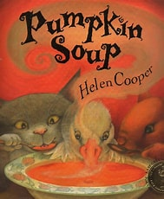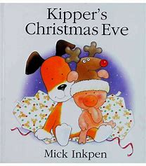 | 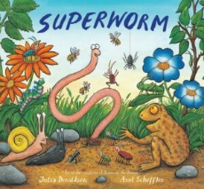  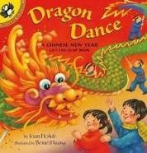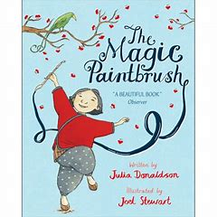 | 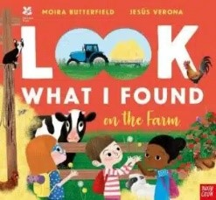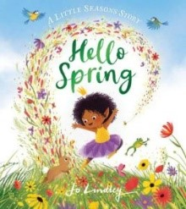  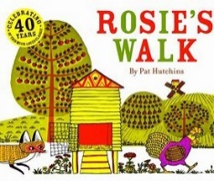  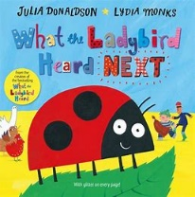  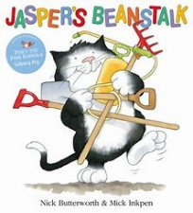 | 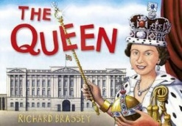  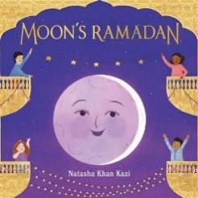 | 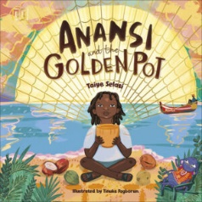  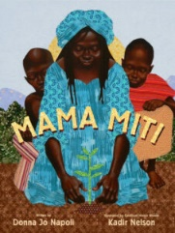  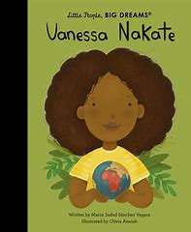
Personal Social and Emotional | My Body and Growing Up  1. To describe their own appearance and name external body parts.  2. To understand ways in which their body has changed since they were a baby.  3. To understand and value what their bodies can do.  5. To understand ways of looking after their body and keeping it clean. (MS  6. To understand ways in which they can take responsibility for keeping themselves clean and recognise situations where they still need to be supported by others. (MS)  4. To recognise similarities and differences between the bodies of girls and boys, including using agreed names for the sexual parts  7. To understand how members of their family and other trusted people care for and look after them  8. To recognise how they feel about growing up.  Beginning and Belonging  1. To understand what is special about me and other people in my class.  3. To know who and how to ask for help if they need it.  4. To understand ways of welcoming new children to the class  2. To understand what I have learnt to do and recognise what I would like to do next. (SR)  5. To understand ways of respecting the needs of other children in the class. (MS)  6. To begin to understand how to play and work alongside others at school. (SR)  7. To know how to show I am listening to an adult. (SR)  8. To be able to follow simple instructions. (SR) | Family and Friends (incl. anti-bullying week)  1. To identify who is special to me and what makes them special. (BR)  2. To say who is in my family and how my family care for one another. (BR)  3. To understand what a friend is, and what a good friend might do. (BR)  4. To know some ways to make new friends. (BR)  5. To know how to respect my own needs and how to show respect to the needs of others. (BR)  6. To know some simple strategies to use to make up with friends after falling out. (BR)  7. To know some simple strategies to use to make up with friends after falling out. (BR)  8. To recognise some forms of unkind behaviour, and know what to do if someone is unkind to me. (BR) | My Emotions  To recognise and identify feelings in themselves and others. (SR)  To recognise what might cause different feelings in themselves and others. (SR)  To recognise how they might feel, and how others might feel, if something changes or if they lose something. (SR)  To recognise simple ways of helping themselves feel better (SR)  To recognise ways of helping others feel better (SR)  To understand what it is meant by perseverance and give examples of how they might do this. (MS) | Me and My World  1. To identify some of the people who look after them and their school. (PP)  3. To understand some things I can do to show care for things at home  6. To understand some ways of looking after the local environment to keep it special for everyone.  7. To understand what a plant or animal needs to live, and know some ways of caring for them  8. To understand the sorts of things that people have to pay for and how they pay for them | Keeping Safe  (incl. Drug Education)  1. To be able to recognise the clues my body gives me when I am feeling unsafe or unsure. (MS)  2. To be able to identify trusted adults who I could talk to and ask for help. (PP)  6. To develop a strategy to keep safer if I am lost.  7. To be able to identify safer places to play.  8. To understand basic road safety skills.  9. To be able to plan ahead to keep safer and apply safety rules in different contexts (e.g. sun, water, fire, railways).  12. To be able to recognise a secret and to know that I can tell a trusted adult if I am worried about a secret. (SR)  13. To know what goes on to and in to my body. (MS)  14. To understand what medicines are and why some people need medicines. (MS) week 6 | Healthy Lifestyles  1. To understand what their bodies need to stay healthy.  2. To be able to name and talk about foods they like and dislike.  3. To understand why different foods and drink are important for their bodies. (MS)  4. To understand what exercise is and why it is good for them.  5. To understand the importance of sleep for their bodies.  6. To be able to name some choices they can make which contribute to healthy living. (MS)
Communication and Language | Nursery rhymes  Circle times -  - What is your favourite colour?  - If you were a balloon, where would you go?  - Finding out about our new friends  - Talking about our families  - My name is... | Circle Time  Story time  Reading Buddies  NELI | Circle Time  Story time  Reading Buddies  NELI | Circle Time  Spring Walk – what do you notice?  Story time  Reading Buddies  Talk partners  NELI | Circle Time  Story Time  Reading Buddies  Talk partners  NELI | Class Assembly - Speaking to an audience  Circle Time  Story Time  Reading Buddies  Talk partners  NELI
Communication and Language | Big Questions  What makes Britain great? (Cycle A)  What is means to be a hero? (Cycle B)  What makes a family?  Where in the world is Gamlingay?  What makes us the same/different?  What makes us special? | Big Questions  What makes Britain great? (Cycle A)  What is means to be a hero? (Cycle B)  How do people celebrate Christmas?  What animals live in the woods?  What do you find in the woods?  What are the signs of Autumn/Winter? | Big Questions  What is our footprint on the world? (Cycle A)  What is our window on the world? (Cycle B)  What makes a good superhero?  How did Superworm help his friends at the end?  How could we help our friends?  Who are real life Superheroes? | Big Questions  What is our footprint on the world? (Cycle A)  What is our window on the world? (Cycle B)  What are the signs of Spring?  What animals live on a farm?  What products do we get from farm animals? | Big Questions  What makes our life magical? (Cycle A)  Why is weather wonderful? (Cycle B)  What is a castle?  Where do we live?  Who lives in a castle?  What might you see in a castle?  Why were castles built?  What does a castle look like? | Big Questions  What makes our life magical? (Cycle A)  Why is weather wonderful? (Cycle B)  Which animals live in Africa? Where is Africa?  What are animal families? What is a mammal?  What is a city?  What are the differences between Gamlingay and city in Africa?
Physical Development | Balanceability  Gross motor skills  Handwriting- patterns  Dough Disco | PE – Jumping  - Exploring and developing jumping.  - Applying jumping technique to a game.  - Exploring distance, height and direction. | PE – Dance  - Exploring different movements using the body.  - Exploring rhythm and expression.  - Working with a partner. | PE – Gymnastics  - Exploring high and low movements.  - Applying learning to apparatus. | PE – Gymnastics  - Making shapes and moving using different body parts.  - Exploring direction and size of movements.  - Working in pairs. | PE – attack and defence games.  - Taking turns, keeping score and following rules.  - Defending and attacking in a game.  Sports Day
Literacy | Correct letter formation for name  Recognising and forming phase 2 phonemes  Oral blending  CVC words – reading and writing | Correct letter formation for name  Recognising and forming phase 2 phonemes  Oral blending  CVC words – reading and writing  Sequencing the Christmas story  Recognising Tricky words | Phase 3 words, captions and sentences  People who help us caption writing  Chinese New Year caption writing  Recognising Tricky lwords | Phase 3 words, captions and sentences  Writing bread instructions  Writing shopping lists  Creating I spy lists  Story jumps – Little Red Hen  Farm captions  Recognising and writing tricky words  Sequencing the Easter story  Sequencing the Little Red Hen | Phase 4 words, captions and sentences  Recognising and writing tricky words  Write a class fact book about castles and castle life  Phonics writing  Banquet invitiations  Write their own story | Phase 4 words, captions and sentences  Recognising and writing tricky words  Fact file passports – weekly updates about what they have learnt about the country they have visited  Phonics writing
Literacy | Message centre | Drawing Club  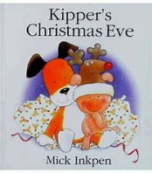 | Drawing Club | Drawing Club | Drawing Club  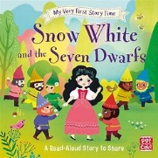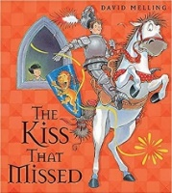 | Drawing Club  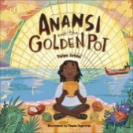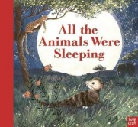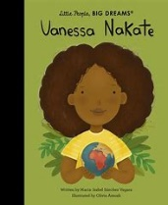
Phonics | Phase 1  Little Wandle Phase 2 – s, a, t, p, i, n, m, d, g, o, c, k, ck, e, u, r, h, b, f, l  Reading groups | Little Wandle Phase 2 - ff, ll, ss, j, v, w, x, y, z, qu, ch, sh, th, ng, nk  Reading groups | Little Wandle Phase 3 - ai, ee, igh, oa, oo, oo, ar, or, ur, ow, oi, ear, air, er  Reading Groups | Little Wandle Phase 3 – ai, ee, igh, oa, oo, ar, or, ur, oo, ow, oi, ear, er, air, double letters, longer words, words with two or more digraphs, longer words, words ending in –ing, compound words, longer words, /z/, /s/, /iz/  Reading Groups | Little Wandle Phase 4 - short vowels CCVCC, CCCVC, CCCVCC, longer words, short vowels CCVCC, CCCVC, CCCVCC, longer words, root words ending in: –ing, –ed /t/, –ed /id/ /ed/ –est  Reading Groups | Little Wandle Phase 4 - long vowel sounds CCVC, CCCVC, CCV CCVCC, words ending –s /s/, Phase 4 words ending –s /z/, Phase 4 words ending –es,  longer words, root word ending in: –ing, –ed /t/, –ed /id/ /ed/, –ed /d/, Phase 4 words ending in:  –s /s/, –s /z/, –es, longer words  Reading Groups
Mathematics | Maths Mastery- NCTEM  Develop subitising in a range of contexts up to 3.  Develop understanding of cardinality, counting and ordinality through range of opportunities such as rhyme and song.  Understand that all numbers can be made of 1s.  Compare sets by looking, use language more than/fewer than. | Maths Mastery- NCTEM  Subitise within 5, perceptually and conceptually, depending on the arrangements. Counting beyond 5.  Explore cardinality of 5 using dice and fingers. Recognise numerals and count beyond 5.  Explore concept of wholes and parts. Explore composition of 5.  Compare sets by subitising and matching objects to see if they are equal.  Shape | Maths Mastery- NCTEM  Subitising up to 5 in random arrangements. Explore 1 more. Matching arrangements to finger patterns in numbers greater than 5,  Verbal counting beyond 20. Order numbers linking cardinal and ordinal representations of number.  Continue to explore the composition of 5 and 6 and practise recalling ‘missing’ or ‘hidden’ parts for 5. See that numbers within 10 can be composed of 5 and a bit.  Continue comparing sets using comparison language. Identify when sets are equal. | Maths Mastery- NCTEM  Explore symmetrical patterns in which each side is a familiar pattern, linking this to ‘doubles’.  Continue to consolidate their understanding of cardinality, working with larger numbers within 10. Become more familiar with the counting pattern beyond 20.  Explore the composition of odd and even numbers, looking at the ‘shape’ of these numbers. Begin to link even numbers to doubles, Begin to explore the composition of numbers within 10.  Compare numbers, reasoning about which is more, using both an understanding of the ‘howmanyness’ of a number, and its position in the number system.  Measuring height and length | Maths Mastery- NCTEM  Continue subitising arrangements, including those with 1 more or doubles. Identify when to count and when to subitise.  Verbal counting to 20 and beyond, including from different starting numbers.  Explore composition of 10.  Order sets of objects | Maths Mastery- NCTEM  The children will consolidate their understanding of concepts previously taught through working in a variety of contexts and with different numbers
Understanding the World | Judaism  Parts of body- Link to RSE  Changes to them since a baby – timeline 0-4/5  Giant map of Gamlingay with pictures of children’s houses on it  Families and communities  Introduction to Forest School  Maps  Sound | Bonfire Night  Diwali/Hinduism  What do you find in the woods?  Rememberance Day  Christmas story  Ipads – camera and zooming in – signs of autumn | Chinese New Year  Real life superheroes/people who help us  Science experiment – Materials - What material is the best material for Supertato’s cape?  Science experiment – Floating and Sinking - What material is the best to make a boat for a Superhero?  Science – Can you free the vegetables from the ice? | Easter story/Christianity  Mothers day  Animals  Lifecycles  Planting  Bread making  Maps  Mothers and their Young  Parts of a plant | Ramadan /Islam  Life in the past  Who lives in a castle?  Where do we live?  Maps of Gamlingay  Ipads – app to make stories come alive | Fathers day  Compare different parts of Africa  Compare a city in Africa to Gamlingay/London  Food chains and habitats of African animals
Understanding the World | Scientist of the term  Sound - Laser Physics – Prof. Colin Webb   | Scientist of the term  Weather – Meterologist – Alexander Buchan  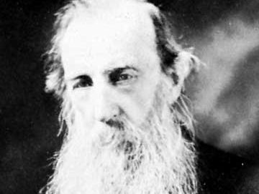 | Scientist of the term  Materials - Civil Engineer – Jyoti Sehdev,  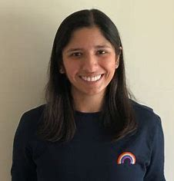 | Scientist of the term  Animals – Veterinary surgeon - Daniella Dos Santos   | Scientist of the term  Castles - Mechanical Engineer – Rafsan Chowdhury  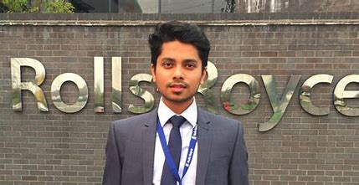 | Scientist of the term  Africa - Animal Scientist – Hella Péter  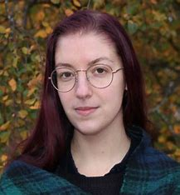
Expressive Art and Design | Singing nursery rhymes  Use of continuous provision- how to use/carry scissors, wind gluesticks up/down, lids on pen, apron etc  Painting - Paint a picture of their family  Painting - Paint a paper plate face  Pens - Design a house with their family in it | Colour mixing  Junk Modelling - Make their own cereal box Gruffalo  Gruffalo hunt  Gruffalo Cafe  Christmas cards  Cutting - Christmas decorations  Cooking – Pumpkin Soup  Clay - Make diva lamps  Split pin Stickmen | Use of different media (paint, felt tips, crayons, pastels, chalks) - Chinese Dragon masks  Cooking - Make stir fry  Food Tasting - Taste prawn crackers and fortune cookies  Food Tasting - Vegetable tasting  Chinese Dragon dance  Make their own Supertato with a potato | Observational drawings and paintings of the meadows  Cooking - Baking bread  Easter cards  Mother’s Day cards | Printing  Cooking - Make jam tarts  Cooking - Make sandwiches  Glueing - Make crowns  Group collage – banners for hall  Designing - Shields with coats of armour on  Junk modelling – making castles  Father’s day cards | Class assembly – performance  Make their own passports  African Artwork  Puppets  African Dance
Expressive Art and Design | Artist of the term  Picasso  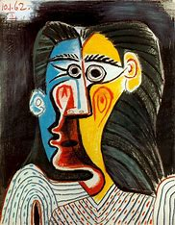 | Artist of the term  James Brunt  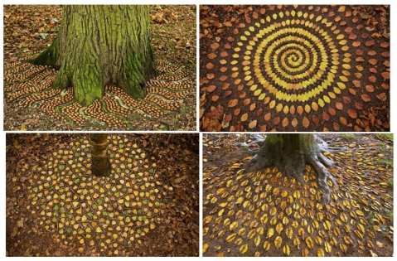 | Artist of the term  Chen Hongshu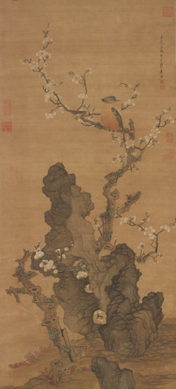 | Artist of the term  Vincent Van Gogh  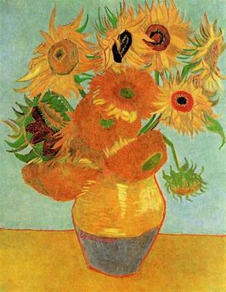 | Artist of the term  Brian Palmer  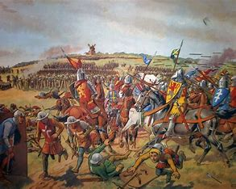 | Artist of the term  Ester Mahlangu  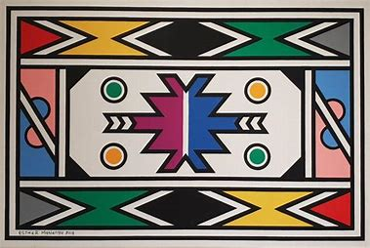
Trips/  Visitors/  Experiences | Grandparents – changes | Eco-Hub Library visit – story time and deliver Santa letters  Decoration Day – Parents to come in  Walk the path of Sita | Fire engine visit  Nurse visit  Detective visit  Scientist visit  Superhero training day  People who help us around the school visitors – Mr G, Mrs Desborough, Mr Gilbett, Miss Henry, Mrs Pearce. | Farm visit  Visitor- growing potatoes - kitchen garden  Meadows walk – signs of Spring  Knotts Farm – Lamb feeding in the classroom  Mystery reader – parents to come in and read to the children | Banquet day  Mystery reader – parents to come in and read to the children | Airport experience – Flying to Africa  Mystery reader – parents to come in and read to the children

